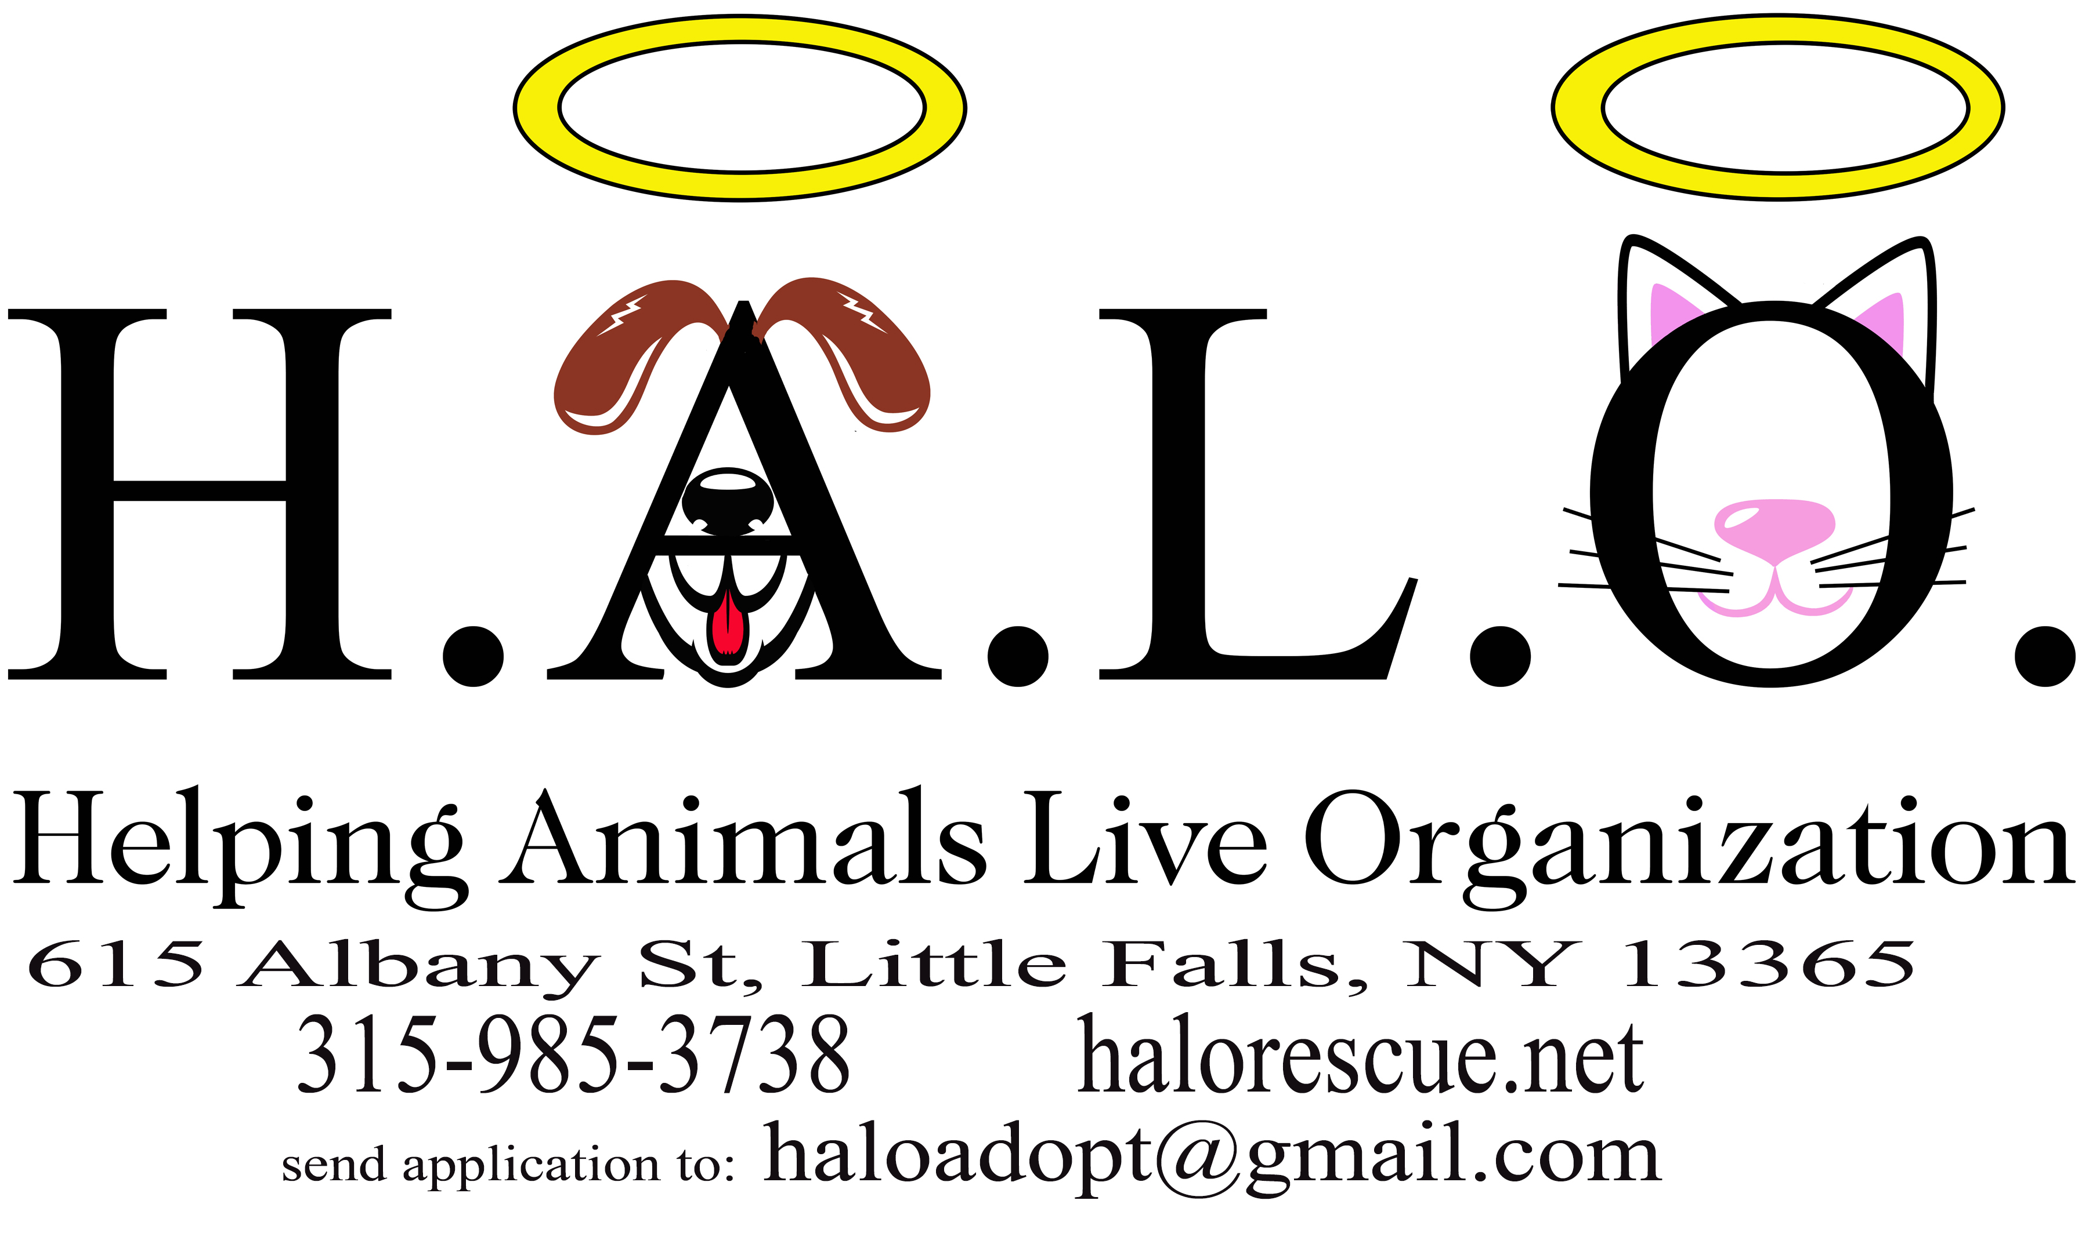

APPLICANT:
ADDRESS:
CITY: STATE: ZIP: ____________
PHONE: (h) (c) (w)
E-MAIL:

Completion of this form is required before your adoption will be considered. Applications may require a minimum 48-hour review. H.A.L.O. reserves the right to refuse any adoption in the best interest of the animal.
Please note: There will be careful consideration before placement to families with children under six years of age.

IN ORDER TO BE CONSIDERED AS AN ADOPTER, YOU MUST:

- Be 21 years of age or older
- Have the knowledge and consent of your landlord
- Be able and willing to spend the time, money and effort to provide the care and attention needed by a pet.

Please Answer the Following:

1. What kind of pet are you here to adopt? Cat Kitten Other
2. Would you consider an animal with special needs? Yes No
3. Why do you want to adopt? Are you seeking a . . . (Check all that apply)
(a) companion for yourself (b) companion for a child (c) barn cat/mouser
(d) companion for another pet (e) Other (specify)
4. Do you have any pets at this time? Y / N If yes, please answer the following:
NAME BREED/SPECIES AGE SPAYED/NEUTERED

Maintaining a pet can be costly. In addition to food and medication, a pet needs to be seen by a veterinarian at least once a year for annual vaccinations and check-ups.
5. Beyond annual check-ups, a pet will occasionally need to see a vet due to illness or accident. A
routine vet visit generally ranges from $50 to $100. Once you adopt a pet, H.A.L.O cannot
assume further financial responsibility because of illness.
Do you understand that, after you adopt a pet, you are responsible for its health care? Y / N
Are you prepared to meet these costs? Y / N
Do you plan on declawing the cat? Y / N
6. Veterinarian: Phone No.
7. Do you currently live in a: house apartment mobile home other
IF YOU RENT:
- Have you checked with your landlord to see if pets are allowed? Y / N
- Have you discussed with your landlord and agreed upon such matters as damage deposits and the cost of any repairs that might be needed? Y / N
- What is your landlord's name Phone #
8. How many people are there in your household?
Is everyone in your home aware that you are considering pet adoption? Y / N
Has everyone agreed to the potential adoption? Y / N
Is anyone allergic to pet hair and dander? Y / N
Will children be involved in daily care? Y / N If yes, what are their ages?
Is someone home during the day? Y / N If no, how long will the pet be alone?
9. Where will the animal be housed during the day? At night?
A new pet will take time to adjust to you, the new environment, other pets and new routines.
10. Do you intend to move over the next year? Y / N
11. Have you ever given up a pet? Y / N
If yes, to whom? Why?
12. It is part of H.A.L.O.'s policy to follow-up on every adoption to see how you and your new pet
are doing. This is routinely done by a volunteer via a phone call or by a home visit.
Is this acceptable to you? Y / N
13. Is there anything you would like to add that will help us find the right pet for you?

14. How did you hear about H.A.L.O?

Please give us the name and phone # of two references (non-family members)

1. Phone:

2. Phone:

I ACKNOWLEDGE THE ABOVE INFORMATION TO BE TRUE.

By signing below, I am attesting to the truthfulness of my answers. Falsification of any of the above information will be grounds for rejection of this application and possible removal of adopted pet from my home. I consent to H.A.L.O. representatives discussing information on this application with any persons named on this application.

Signed: Date:

Email to: haloadopt@gmail.com
Mail or return to: H.A.L.O, 615 Albany Street, Little Falls, NY 13365

If you have any questions, please call: 315-985-3738

---------------------------------------------------------------------------------------------------------------------

ADOPTION AGREEMENT

Companion Animal Being Adopted:

Foster Parent:

I agree that through adopting this companion animal from H.A.L.O. I will provide regular veterinary care and will consider the animal a member of my family for as long as he/she lives.

Date:
Signature

In some occasions, a kitten is too young to have been seen by a vet. Adoption can be completed and kitten held at HALO until vetting is complete. In this case a non-refundable fee is collected at time adoption is approved. **only exception: fee will be refunded ONLY if a health issue is discovered prior to placement**

Adoption Fee: $ paid date:____________

**Note: In the rare occasion in which a cat/kitten is placed prior to Vetting, Adopter releases HALO from all responsibilities of health information knowledge. This does not exclude the need to return cat/kitten to be Spay/Neutered .

Signatures: Date:

